### **QR code security issues**

QR codes have numerous useful applications, bad actors can also use them for malicious purposes. In January 2022, the FBI released a warning that cybercriminals may tamper with QR codes to direct victims to malicious websites.

A study conducted last year by MobileIron states that while the majority of people (67%) know that a QR code opens a URL, 71% could not distinguish between a legitimate and malicious QR code.

**There are two main types of QR code exploits that cybercriminals use:**

**QR code-based phishing attack**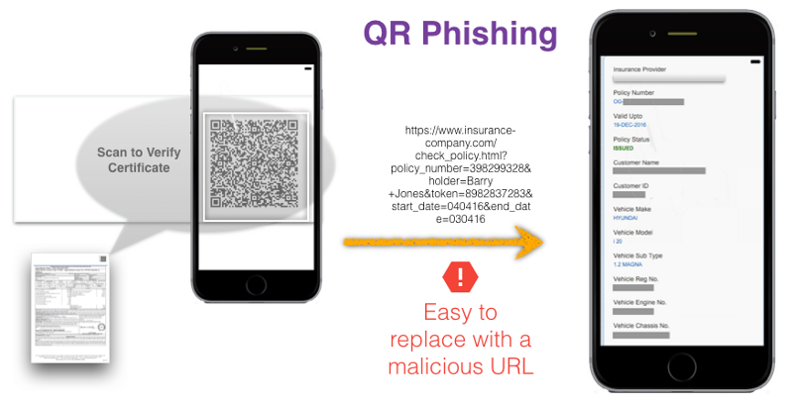

[source](https://www.qryptal.com/blog/qr-phishing-stop-placing-urls-in-qr-codes-when-security-and-privacy-is-paramount/)

This attack uses a QR code to lure a victim to a phishing page that hackers have designed to steal the victim's credentials, personal data or other sensitive information.

**QRLjacking**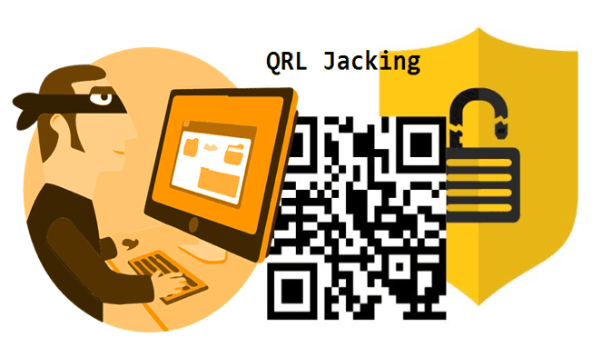

[**source**](https://jtechcode.blogspot.com/2020/03/whatsapp-session-hijacking-using.html)

In this type of attack, hackers use a QR code to spread malware to the victim's device. The attacker tricks the user into scanning a QR code that directs the user's device to a malicious URL, which infects the device with malware.

**How organizations can protect against the dangers of QR codes:**

There are three things that organizations must do to protect users against QR code-based attacks. Consider the following steps to avoid the potential consequences of a fraudulent QR code:

Make sure that users are running security software on any mobile device that has access to corporate resources. The software should be able to protect against device takeover attacks, phishing attacks and other mobile device exploits.

Educate users on the cybersecurity dangers associated with scanning QR codes. Otherwise, users may not realize that QR codes can be problematic.

Implement multifactor authentication (MFA) requirements across the organization as an interim, and then gradually work on adopting an authentication solution that does not rely on passwords. Many QR code-based attacks are designed to trick users into entering their passwords so that cybercriminals can steal their credentials. Working toward the elimination of passwords can help to thwart these types of attacks.

QR codes are tricky because you cannot find out by simply looking at the code. Because the vulnerability is practically part of the design, consider downloading an app on phone which provides a preview to each code before it opens a webpage. This way, we will have right to refuse the QR code if it is corrupted.